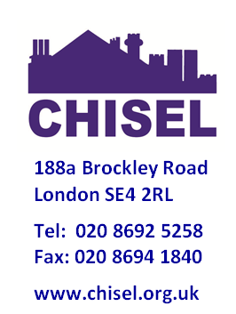

Information for residents following the fire at Grenfell Tower

A major fire broke out on Tuesday 13 June at the 24-storey Grenfell Tower in West London. As of Monday 19 June, 79 people are presumed dead or missing. Our thoughts are with those affected.

We want to reassure our tenants that their safety is taken extremely seriously across CHISEL.

General fire safety advice is included below and is also available at:

[www.london-fire.gov.uk/FireSafety.asp](http://www.genesisha.org.uk/www.london-fire.gov.uk/FireSafety.asp)

**What is CHISEL doing to help keep residents safe from risks of fire?**

* We undertake fire risk assessments (FRA’s) in all our shared housing, blocks of flats, and houses that are converted into flats which are above 3 storeys. These are undertaken by a suitably qualified external consultant.
* We are embarking on a planned programme of scheme inspections to ensure all communal areas are kept clear from fire risks.

**Fire Safety Advice for residents**

Here are some precautions you can take to help keep your home and family safe from fire:

* **Test your smoke alarm weekly by pressing the button**. Keep your smoke alarm free of dust and keep spare batteries handy. You can find more information on this at: [www.fireservice.co.uk/safety/smoke-alarms](http://www.genesisha.org.uk/www.fireservice.co.uk/safety/smoke-alarms)
* It is safer not to smoke but if you do, try to smoke outside. Never smoke in bed (or anywhere else where you might fall asleep), make sure cigarettes are properly stubbed out and never throw hot ash in bins
* Keep matches and lighters away from children
* Take care with candles: use proper holders and keep them away from curtains, furniture and clothes
* Don’t overload electrical sockets, try and keep to one plug per socket. Certain appliance, like washing machines should have a single plug to themselves, as they are high powered.
* Make sure electrical appliances have a British or European safety mark when you buy them.
* Never leave pans unattended when cooking
* Avoid the use of pans full of oil for cooking. If the pan does catch fire, never throw water on it. Cover the pan with a damp tea towel and turn off the heat. If the pan is still alight, leave the room, shut the door, warn others and call 999.
* **If you have door closers fitted, don’t wedge the door open or remove the closer**
* When you go to bed, make sure all candles are out and cookers and heaters are turned off. Close doors when you go to bed to stop fires spreading
* Switch off any non-essential electrical items like TVs at the mains and don’t charge mobiles and laptops overnight.
* Do not leave appliances such as dishwashers and tumble running when you leave the house.
* **Never bring motorbikes, mopeds or motor scooters inside the property.**
* Don’t use fire pits, BBQ’s and other outdoor equipment designed to be used outdoors inside your home.
* **Don’t store anything in common areas such as corridors or electrical cupboards. Wanted or unwanted items left in shared areas, landings or corridors can act as fuel for a fire and can also prevent people escaping in the event of a fire.**
* **Know your escape route before a fire happens**

Simple measures such as this reduce fire risk. We thank you for your continued co-operation on this matter.

**Let’s stay Safe!**